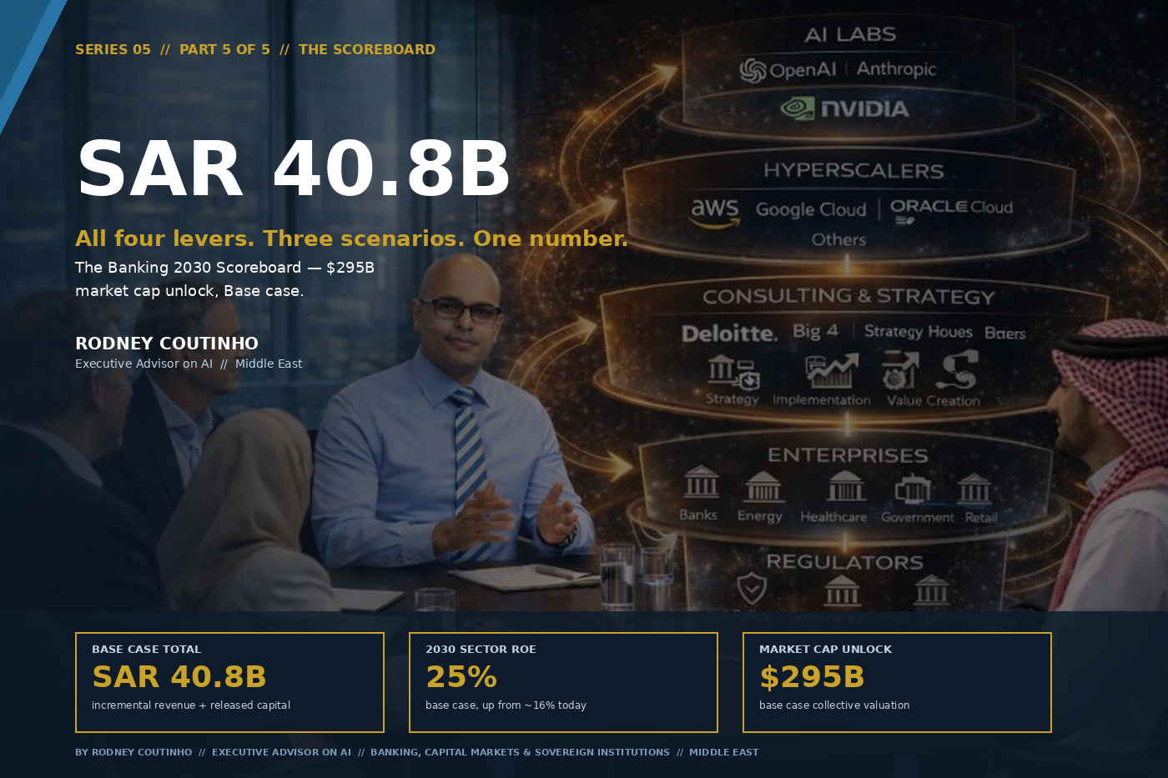

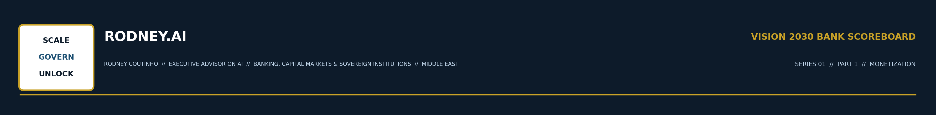
SERIES 05 // THE VISION 2030 BANK SCOREBOARD // PART 5 OF 5 // THE SCOREBOARD
All Four Levers, Three Scenarios, One Number for the Board
By Rodney Coutinho
Executive Advisor on AI // Banking, Capital Markets & Sovereign Institutions // Middle East
For four weeks, this series has sized individual levers. Monetization. Tokenization. Capital Efficiency. Sovereign Ecosystem. Each one a separate argument, a separate business case, a separate slide deck competing for board attention.
Part 5 is the slide that makes the other four unnecessary. The Banking 2030 Scoreboard combines all four levers into a single annual value: SAR 40.8 billion.
THE SCOREBOARD
SAR 40.8 Billion / Year
Incremental revenue and released capital available to Saudi banks that execute across the full stack. After netting the SAR 1.1B overlap between Monetization and Sovereign Ecosystem.
Low: SAR 19.2B // Base: SAR 40.8B // High: SAR 66.8B // Source: KSA Scoreboard Model

01 // THE FULL SCOREBOARD
All four levers, three scenarios, after overlap adjustment.
LEVER | LOW | BASE | HIGH
L1 · Monetization | 15.9 | 29.5 | 38.6
L2 · Tokenization | 0.5 | 2.7 | 11.9
L3 · Capital Efficiency | 0.5 | 2.5 | 5.3
L4 · Sovereign Ecosystem | 2.7 | 7.1 | 13.7
Less: L1/L4 overlap | (0.3) | (1.1) | (2.7)
TOTAL // SAR B / yr | 19.2 | 40.8 | 66.8

OUTCOME METRIC | LOW | BASE | HIGH
2030 Sector ROE | 21% | 25% | 30%
Market cap unlock | $212B | $295B | $392B

The overlap adjustment reflects the intersection between Monetization (L1) and Sovereign Ecosystem (L4): AI-powered financial products sold to sovereign-ecosystem clients are counted in both levers. The Scoreboard nets this to avoid double-counting.

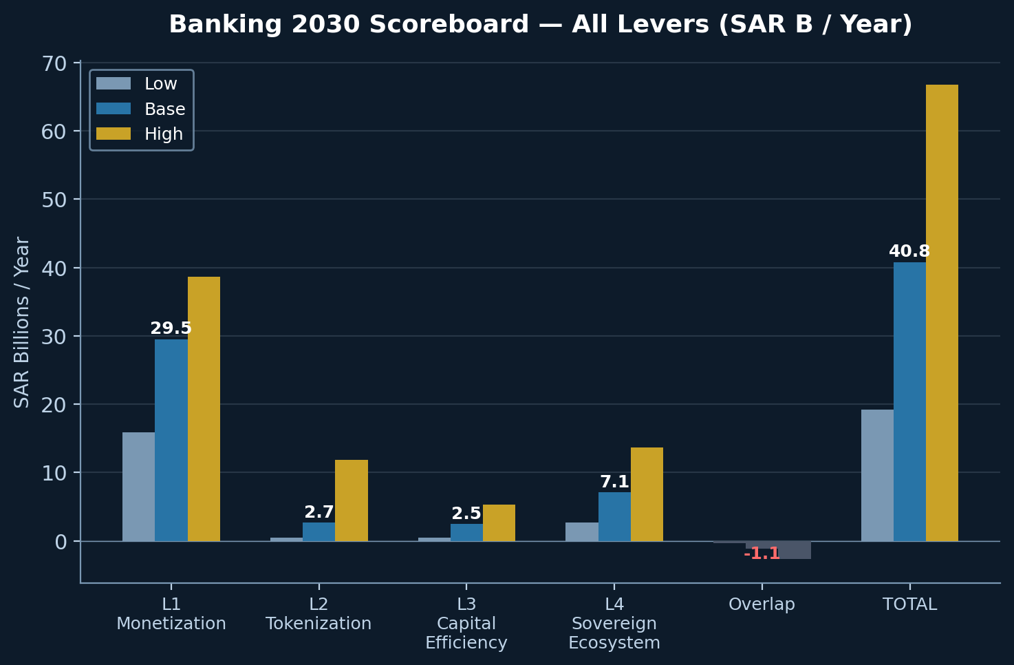

02 // WHY THE LEVERS COMPOUND
The Scoreboard is not an additive model. The levers reinforce each other in ways that make the whole larger than the sum.
Capital Efficiency funds Monetization.
Every SAR released through RWA optimisation (L3) is a SAR available to invest in the BaaS platforms, data products, and API infrastructure that drive new fee pools (L1). A bank that frees SAR 2.5B of capital and deploys it at a 15% marginal ROE generates SAR 375 million of incremental income — before the fee revenue itself.
Sovereign Ecosystem creates Monetization demand.
HUMAIN's AI applications layer will need banking APIs, payment rails, and financial product distribution (L1). The hundreds of thousands of workers on giga-project payrolls need digital wallets, remittance services, and consumer lending products. The sovereign build is not just project finance — it is a customer acquisition engine.
Tokenization enables Capital Efficiency.
A bank that tokenises its sukuk book (L2) gains real-time portfolio visibility and automated compliance — both of which improve RWA calculation accuracy and reduce capital buffers (L3). DLT-based collateral registries eliminate the data quality gaps that cause regulatory capital waste.
Sovereign Ecosystem accelerates Tokenization.
When PIF or CMA endorses on-chain capital markets infrastructure (L4), it de-risks the regulatory path for private tokenised issuance (L2). Government first, private sector follows.

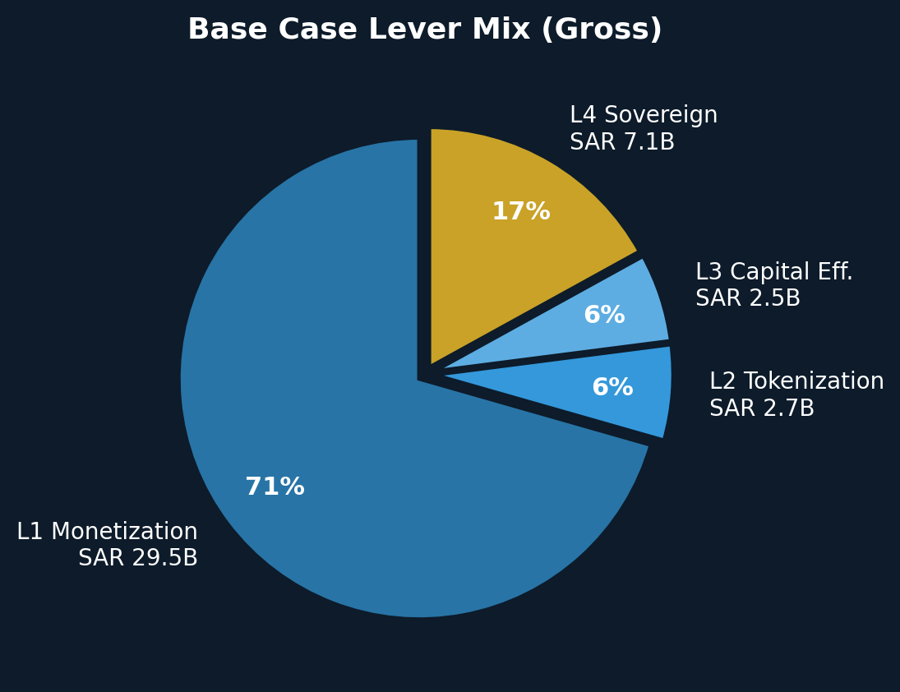

03 // THREE SCENARIOS FOR THE BOARD
Low case: SAR 19.2B / year — the "comply only" path.
Banks meet regulatory requirements (Basel IV, SDAIA governance framework, open banking). They launch AI pilots. They service sovereign clients through standard corporate banking products. They hold capital buffers at regulatory minimums and tokenise nothing. ROE reaches 21% — respectable, but not enough to close the valuation gap with global peers. Market cap: $212B.
Base case: SAR 40.8B / year — the "programme" path.
Banks run coordinated programmes across at least three levers. They have a Monetization unit building data products and BaaS. They run a capital efficiency programme with board-level sponsorship. They bid actively for sovereign ecosystem banking. They explore tokenisation through regulatory sandboxes. ROE reaches 25% — competitive with the best emerging market banking sectors. Market cap: $295B.
High case: SAR 66.8B / year — the "platform" path.
Banks transform into AI-native financial platforms. Every origination decision is optimised for risk-return-capital efficiency. Tokenised instruments are production-grade. The bank is embedded in the sovereign AI ecosystem as an infrastructure partner, not a service provider. ROE reaches 30% — world-class. Market cap: $392B.

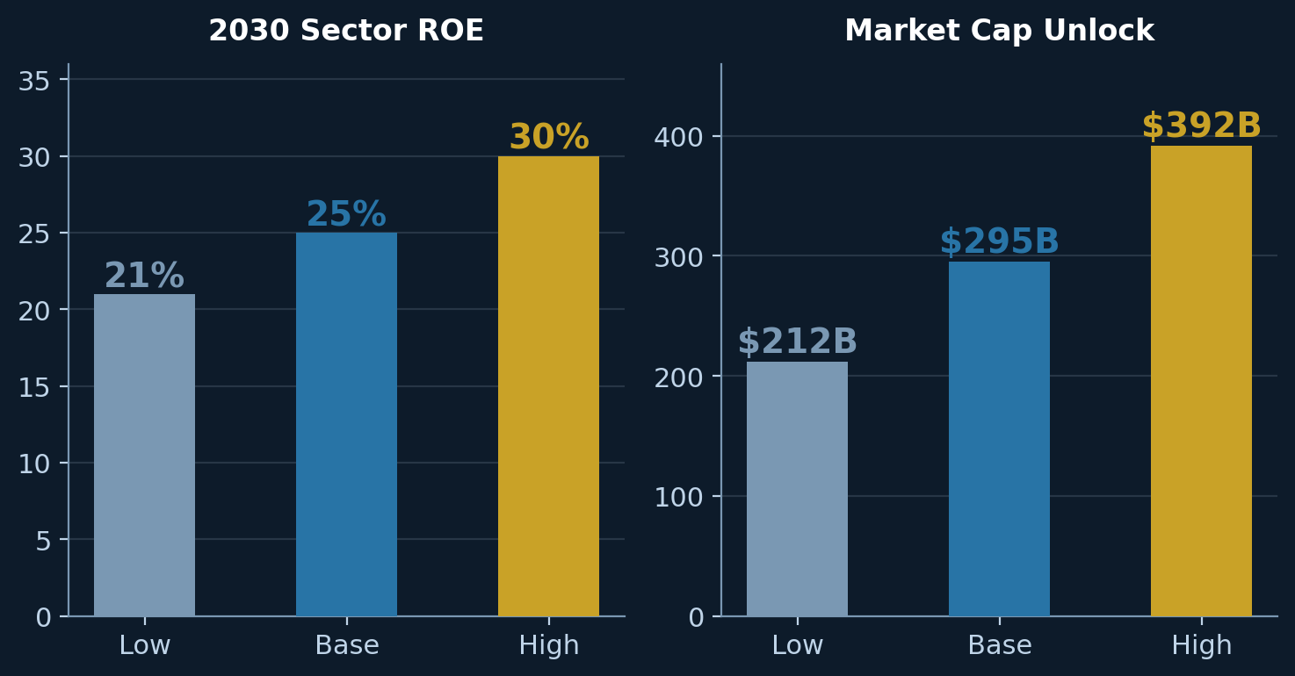

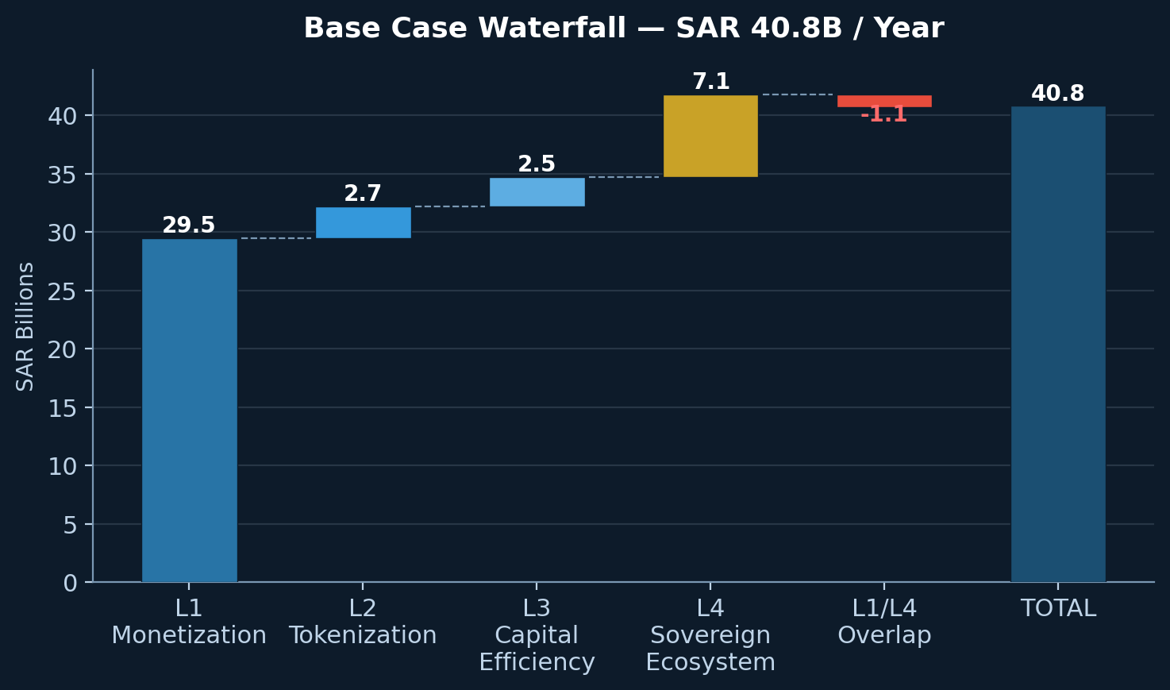

04 // THE EXECUTION GAP
The difference between SAR 19.2B and SAR 66.8B is SAR 47.6B per year. Over five years, that is nearly SAR 240B of cumulative value — or approximately $64 billion.
What separates the scenarios is not technology availability. Every tool referenced in this series exists today. What separates them is governance, integration, and speed.

Governance.
Does the board treat AI as a strategic programme with a named owner, a budget, and a target number? Or is it a collection of uncoordinated pilots scattered across business units?
Integration.
Do the four levers have a single executive sponsor who sees the interactions? Or are Monetization, Tokenization, Capital Efficiency, and Sovereign Ecosystem running in separate silos, each with its own business case and its own governance?
Speed.
The sovereign is moving fast. HUMAIN went from announcement to 200 MW of construction in under a year. PIF restructured into three portfolios in a single board cycle. SDAIA published a mandatory governance framework in months, not years. The question is whether banks can match that velocity.

05 // WHAT A 2030 BANK LOOKS LIKE
The bank that executes across all four levers in 2030 looks fundamentally different from a Saudi bank today.
Balance sheet.
15–30% lower RWA density through IRB migration, collateral optimisation, and active portfolio management. Capital is a strategic resource, not a regulatory buffer.
Revenue mix.
20–30% of non-interest income from data products, embedded finance, BaaS, and Intelligence-as-a-Service. Fee income is recurring, platform-driven, and decoupled from the interest rate cycle.
Technology stack.
Agentic AI in production across credit decisioning, compliance monitoring, customer service, and portfolio optimisation. Not copilots — autonomous workflows with human oversight at decision boundaries.
Market position.
Named sovereign ecosystem banking partner for PIF, HUMAIN, and at least two giga-projects. Not a commodity lender — an infrastructure partner.
Capital markets.
At least one tokenised instrument in production — a sukuk, a deposit token, or a tokenised fund. First-mover in the GCC digital asset ecosystem.

THE SCOREBOARD IS NOT A FORECAST
The numbers in this series are not predictions. They are sizing exercises — structured estimates of how large each lever could be under different execution assumptions.
What the Scoreboard does is make the opportunity cost visible. Every quarter that passes without a programme in place is a quarter of the SAR 40.8B that lands on someone else's balance sheet — or does not materialise at all.

The question is no longer whether these levers exist. It is who captures them first.

ONE QUESTION FOR THE BOARDROOM THIS WEEK
Do you have a single executive who sees all four levers — and owns the programme to capture them?
THE FULL SERIES

01 | Monetization | Growing the top line through fees, data, BaaS and Intelligence-as-a-Service.
02 | Tokenization | Why the first Saudi bank to put sukuk, deposits and real estate on-chain resets the map.
03 | Capital Efficiency | RWA optimisation, Basel IV response and the balance sheet of a 2030 bank.
04 | Sovereign Ecosystem | PIF, HUMAIN, and the demand side of AI.
05 | The Scoreboard | All four levers, three scenarios, one number for the board. (You are here.)

